|  |  |  |  |
| --- | --- | --- | --- |
| Page no. | Topic | Date | Remarks |
| **1** | Abstract |  |  |
| **2** | Introduction |  |  |
| **3** | Components |  |  |
| **4** | Working |  |  |
| **5** | Movements/gestures |  |  |
| **6** | Flow chart |  |  |
| **7** | Circuit Diagram |  |  |
| **8** | Implementation output |  |  |
| **9** | Inference |  |  |
| **10** | Concepts learned |  |  |
| **11** | Applications/Difficulties faced |  |  |

**Abstract**

Handwritten character recognition is one of the practically important issues in pattern

recognition applications. The applications of digit recognition includes in postal mail sorting,

bank check processing, form data entry, etc. The heart of the problem lies within the ability to

develop an efficient algorithm that can recognize hand written digits and which is submitted by

users by the way of a scanner, tablet, and other digital devices. This paper presents an approach

to off-line handwritten digit recognition based on different machine learning technique. The main

objective of this paper is to ensure effective and reliable approaches for recognition of

handwritten digits.

Handwritten character recognition is one of the practically important issues in pattern

recognition applications. The applications of digit recognition includes in postal mail sorting,

bank check processing, form data entry, etc. The heart of the problem lies within the ability to

develop an efficient algorithm that can recognize hand written digits and which is submitted by

users by the way of a scanner, tablet, and other digital devices. This paper presents an approach

to off-line handwritten digit recognition based on different machine learning technique. The main

objective of this paper is to ensure effective and reliable approaches for recognition of

handwritten digits.

Handwritten character recognition is one of the practically important issues in pattern

recognition applications. The applications of digit recognition includes in postal mail sorting,

bank check processing, form data entry, etc. The heart of the problem lies within the ability to

develop an efficient algorithm that can recognize hand written digits and which is submitted by

users by the way of a scanner, tablet, and other digital devices. This paper presents an approach

to off-line handwritten digit recognition based on different machine learning technique. The main

objective of this paper is to ensure effective and reliable approaches for recognition of

handwritten digits.

Handwritten character recognition is one of the

practically important issues in pattern recognition applications.

The applications of digit recognition includes in postal mail

sorting, bank check processing, form data entry, etc. The heart

of the problem lies within the ability to develop an efficient

algorithm that can recognize hand written digits and which is

submitted by users by the way of a scanner, tablet, and other

digital devices. This paper presents an approach to off-line

handwritten digit recognition based on different machine

learning technique. The main objective of this paper is to

ensure effective and reliable approaches for recognition of

handwritten digits

Handwritten character recognition is one of the practically important issues in pattern

recognition applications. The applications of digit recognition includes in postal mail sorting,

bank check processing, form data entry, etc. The heart of the problem lies within the ability to

develop an efficient algorithm that can recognize hand written digits and which is submitted by

users by the way of a scanner, tablet, and other digital devices. This paper presents an approach

to off-line handwritten digit recognition based on different machine learning technique. The main

objective of this paper is to ensure effective and reliable approaches for recognition of

handwritten digits

Handwritten character recognition is one of the practically important issues in pattern

recognition applications. The applications of digit recognition includes in postal mail sorting,

bank check processing, form data entry, etc. The heart of the problem lies within the ability to

develop an efficient algorithm that can recognize hand written digits and which is submitted by

users by the way of a scanner, tablet, and other digital devices. This paper presents an approach

to off-line handwritten digit recognition based on different machine learning technique. The main

objective of this paper is to ensure effective and reliable approaches for recognition of

handwritten digitsHandwritten character recognition is one of the practically important issues in pattern recognition applications. The applications of digit recognition includes in postal mail sorting, bank check processing, form data entry, etc. The heart of the problem lies within the ability to develop an efficient algorithm that can recognize hand written digits and which is submitted by users by the way of a scanner, tablet, and other digital devices. This paper presents an approach to off-line handwritten digit recognition based on different machine learning technique. The main objective of this paper is to ensure effective and reliable approaches for recognition of handwritten digits.

We got inspired from the late Stephan Hawking on how he communicated to everyone though he was paralyzed. Our project would work more efficiently for those paralytic people who cannot communicate using their voice and can at least move their limbs to an extent. We place a sensor on one of their moving limbs, and for each movement, a message would be displayed on the LCD and sounds would be transmitted from the buzzer for every movements.

First the sensor reads the signal and since the signal is analog, we convert this signal to digital using Arduino Uno. This Arduino Uno acts like an Analog to Digital convertor and this is connected to a MPU6050 sensor. This decoder decodes the digital output and sends it to the LCD. The LCD then displays the message for a movement and the buzzer transmits a sound for that movement.

**INTRODUCTION**

The main objective of our project is for those patient who are been diagnose with paralytic problem. These people are unable to communicate using their voice and are only able to move their limbs to an extent. We place a sensor on one of their moving limbs, and for each movement, a message would be displayed on the LCD and sounds would be transmitted from the buzzer for different movements. So that they can communicate with the help of this device.

**COMPONENTS USED**

1. **Arduino Uno**

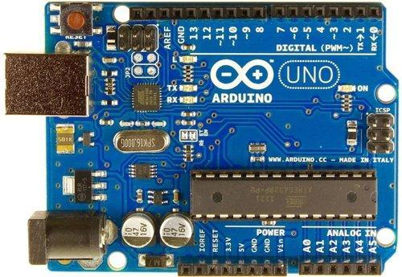

1. **LCD 16*2 Display**

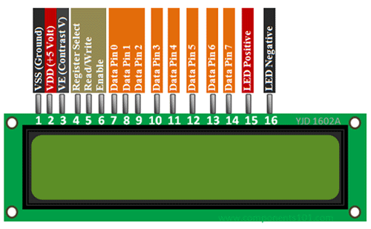

**3) Buzzer**

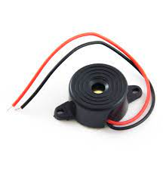

1. **MPU6050 (Gyroscope + Accelerometer + Temperature) Sensor Module**

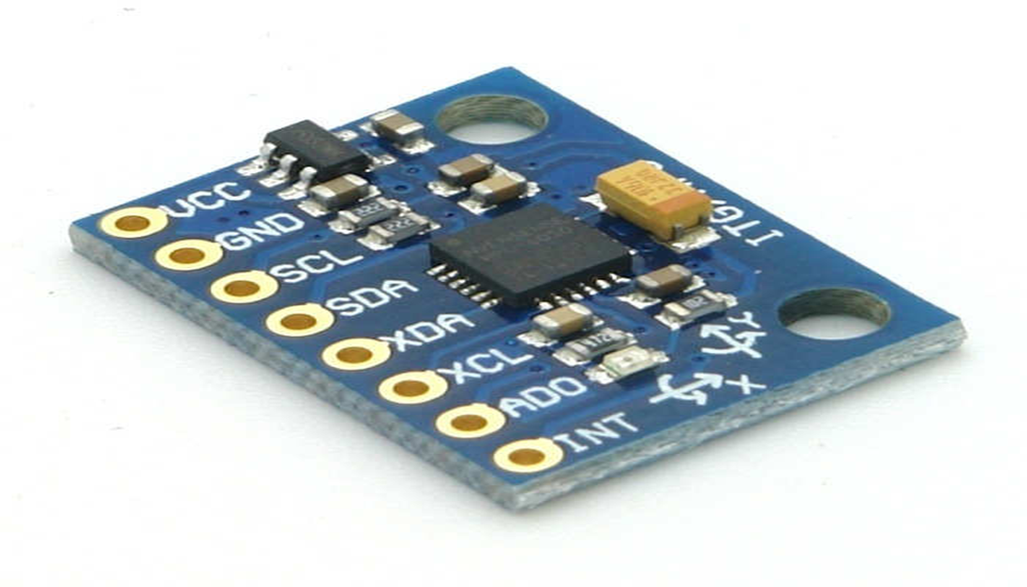

5) Breadboard

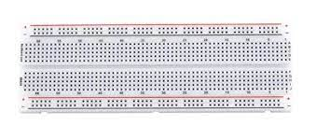

6) Jumper wires

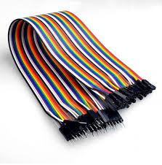

**WORKING**

There will four different option available for the patient that are using this model. The message will be display on the lcd with a buzzer sound that will alert the nurses or doctor that a patient need something.

The four option are:

1. Emergency

2. Need water

3. Need to use the restroom

4. Need medicine

**Movements/Gestures:**

**DOWNWARD UPWARD**



**LEFT RIGHT**

a representation of isolated handwritten digits that allow

their effective recognition. In this paper used different

machine learning algorithm for recognition of

handwritten numerals. In any recognition process, the

important problem is to address the feature extraction

and correct classification approaches. The proposed

algorithm tries to address both the factors and well in

terms of accuracy and time complexity. The overall

highest accuracy 90.37% is achieved in the recognition

process by Multilayer Perceptron. This work is carried

out as an initial attempt, and the aim of the paper is to

facilitate for recognition of handwritten numeral without

using any standard classification techniques

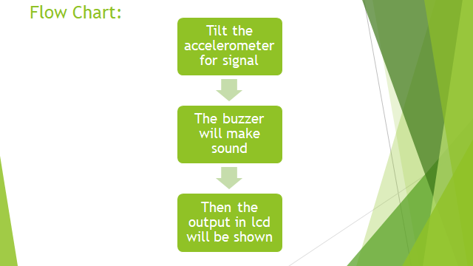

**Circuit Diagram:**

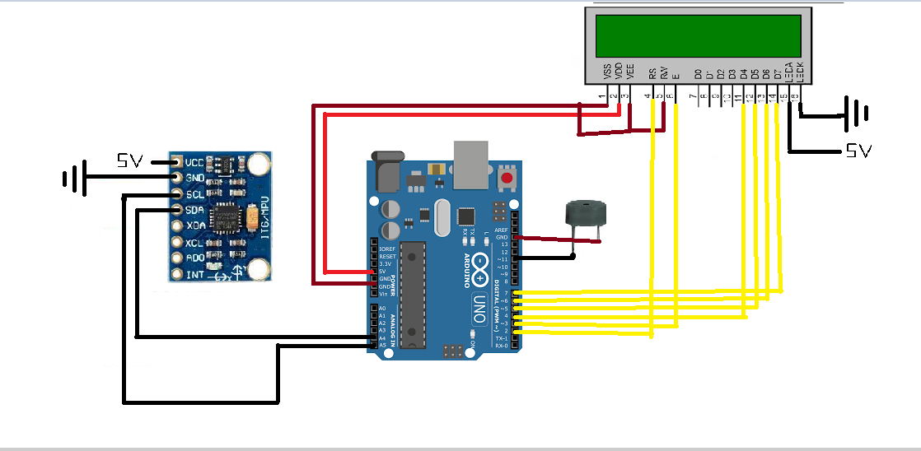

**CODING:**

#include "Wire.h"

#include "I2Cdev.h"

#include "MPU6050.h"

#include <LiquidCrystal.h>

LiquidCrystal lcd(2,3,4,5,6,7);

int buzzer = 11;

int gesture=5;

MPU6050 mpu;

int16_t ax, ay, az;

int16_t gx, gy, gz;

struct MyData {

byte X;

byte Y;

};

MyData data;

void setup()

{

Serial.begin(9600);

Wire.begin();

mpu.initialize();

lcd.begin(16, 2);

pinMode(buzzer, OUTPUT);

lcd.clear();

lcd.print("scanning");

Serial.println("welcome");

}

void loop()

{

mpu.getMotion6(&ax, &ay, &az, &gx, &gy, &gz);

data.X = map(ax, -17000, 17000, 0, 255 ); // X axis data

data.Y = map(ay, -17000, 17000, 0, 255); // Y axis data

if (data.Y < 80) {//gesture : downward

if (gesture!=1){

gesture = 1;

lcd.clear();

Serial.println("RESTROOM");

lcd.print("RESTROOM");

digitalWrite(buzzer, HIGH);

delay(500);

digitalWrite(buzzer,LOW);

delay(500);

}}

if (data.Y > 145) {//gesture : upward

if (gesture!=2){

gesture = 2;

lcd.clear();

Serial.println("NEED MEDICINE");

lcd.print("MEDICINE");

digitalWrite(buzzer, HIGH);

delay(500);

digitalWrite(buzzer,LOW);

delay(500);

}}

if (data.X > 155) {//gesture : left

if (gesture!=3){

gesture = 3;

lcd.clear();

lcd.print("NEED WATER");

Serial.println("NEED WATER");

digitalWrite(buzzer, HIGH);

delay(500);

digitalWrite(buzzer,LOW);

delay(500);

}}

if (data.X < 80) {//gesture : right

if (gesture!=4){

gesture = 4;

lcd.clear();

Serial.println("Emergency");

lcd.print("Emergency");

digitalWrite(buzzer, HIGH);

delay(500);

digitalWrite(buzzer,LOW);

delay(500);

}}

if (data.X > 100 && data.X < 170 && data.Y > 80 && data.Y < 130) { //gesture : little bit down

if (gesture!=5){

gesture = 5;

lcd.clear();

Serial.println(" ");

lcd.print(" ");

digitalWrite(buzzer, HIGH);

delay(500);

digitalWrite(buzzer,LOW);

delay(500);

}}

}

**Implementation Output:**

**Displaying “ EMERGENCY”**

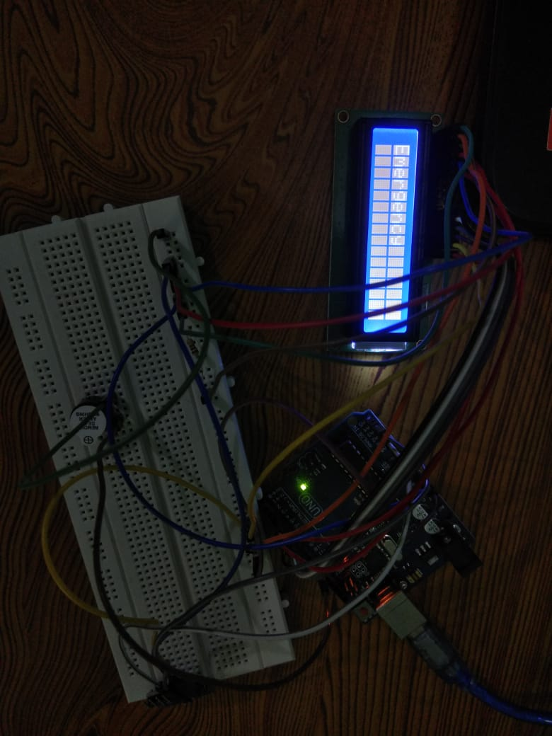

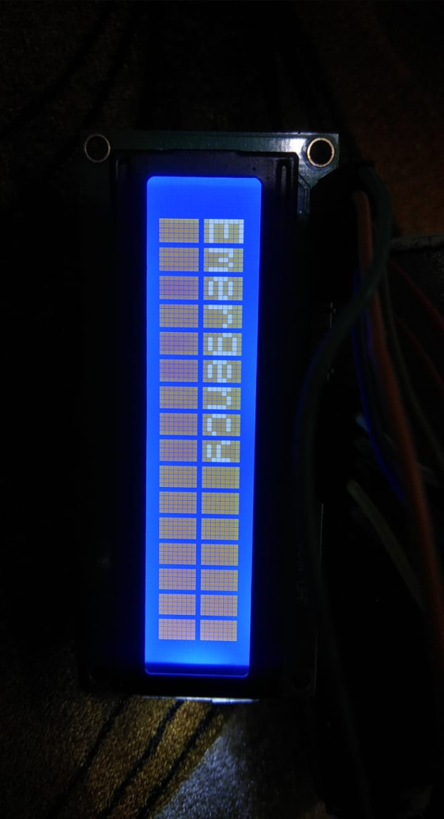

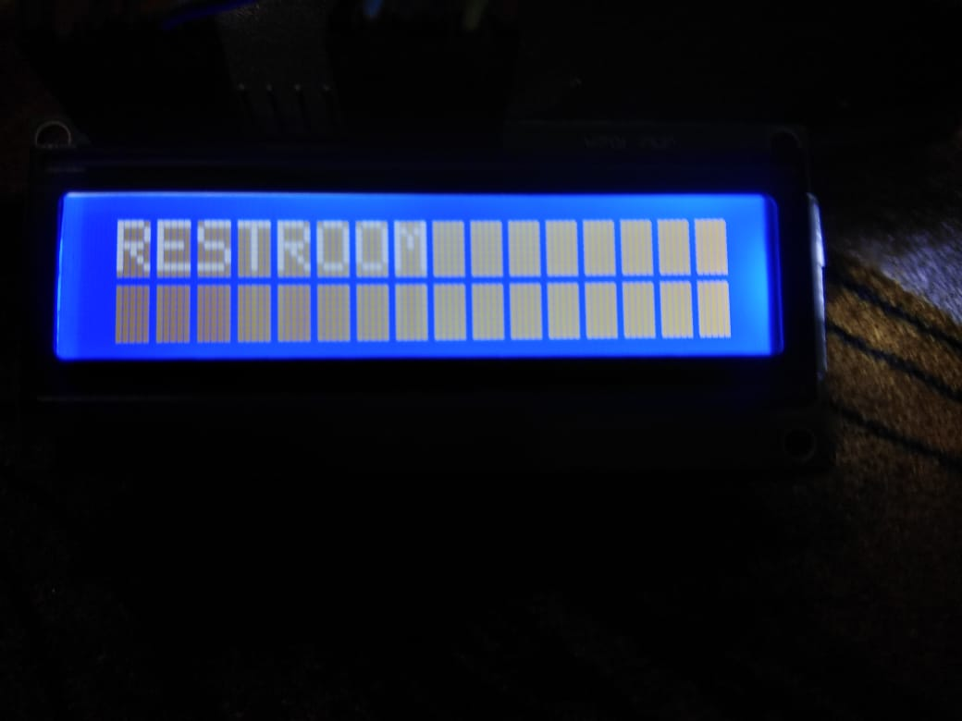

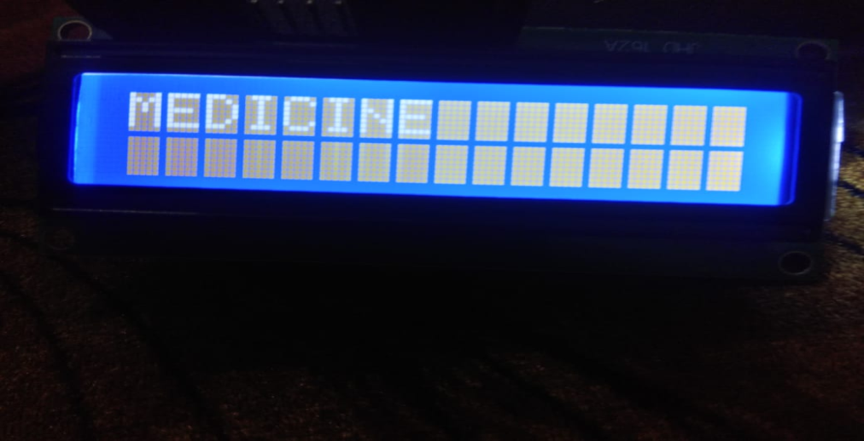

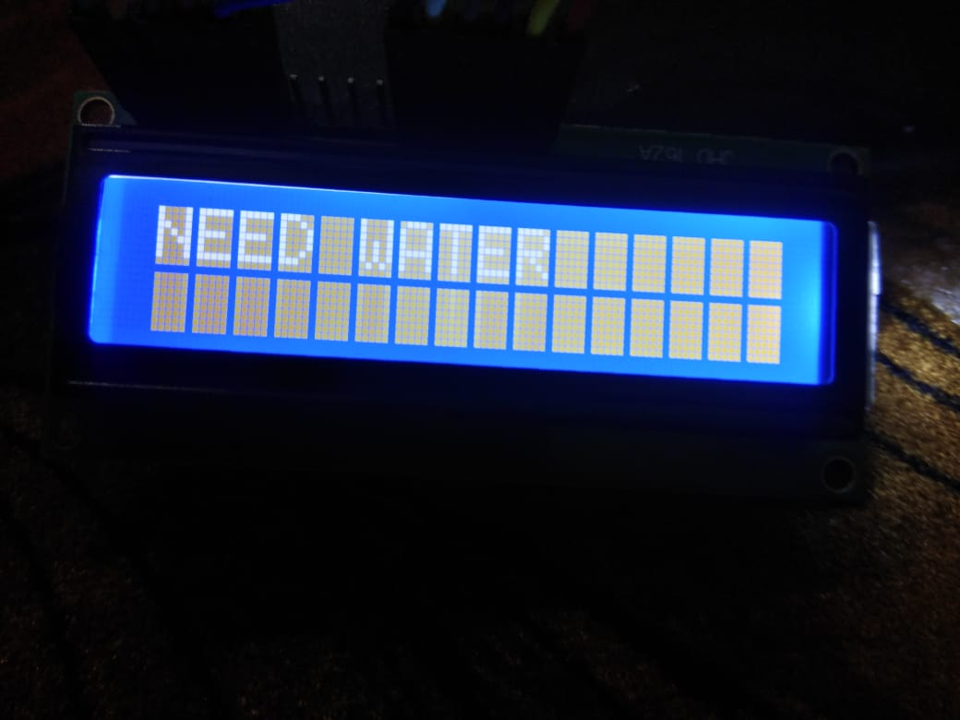

**Inference:**

Thus, we have implemented a prototype of the motion-based message conveyer for patients with difficulties in speech and communication which will assist them is communicating with the nurses and doctors in the time of need.

**Concepts Learned:**

1. The working of mpu6050 sensor.
2. Interfacing of LCD with arduino uno.
3. Arduino programming.
4. Simulating in Proteus and Keil.

**Applications:**

Our model would be applicable for those who are suffering from speech disorders like:

1. Apraxia of speech
2. Cluttering
3. Developmental verbal dyspraxia
4. Speech sound disorders

**Difficulties faced:**

1. Simulation of the code in Proteus.
2. Interfacing LCD with arduino uno.
3. Making the schematic of the project.
4. Preparing the code for the project.